**Practical No 10**

**Name -: Aditya Babaso Birangaddi**

**Roll No -: 47**

**Enrollment No -: 1915770160**

**1] Write Python program to demonstrate math built-in functions (Any 2 programs)**

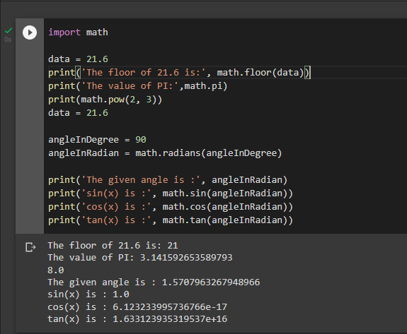

**2] Write Python program to demonstrate string built-in functions (Any 2 programs)**

